How to Check If the Self-signed certificate installed well.

- Check if the Root CA certificate is valid.
  - Go to the ‘cert’ folder under the installation directory and check if the ‘SupremaIntegrationWithNedapAEOS.root.crt’ file exists.
  - Open ‘Windows powershell’ and execute the following (to check the fingerprint of the Root CA certificate). 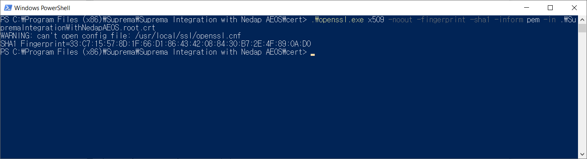
  - Open ‘Manage computer certificates’ and look for ‘Suprema Root CA’. 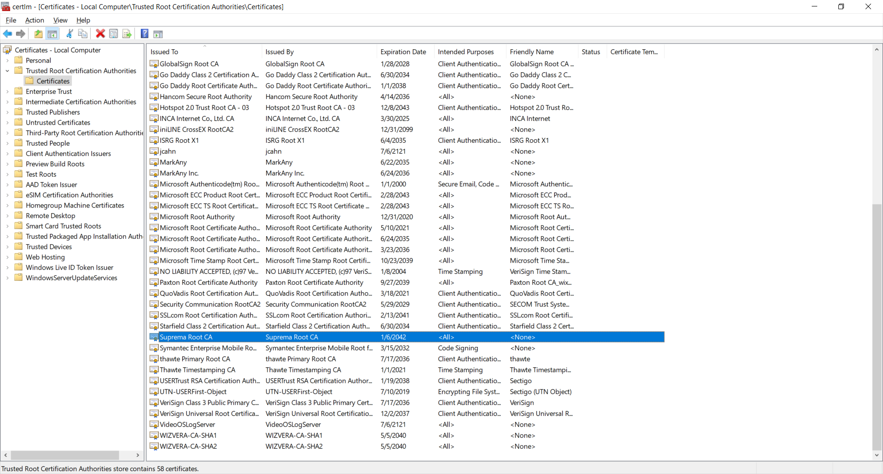
  - Douible-click the ‘Suprema Root CA’ and see the ‘Thumbprint’ 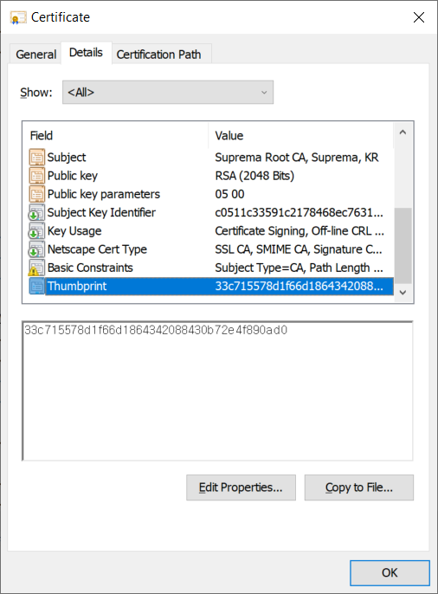
  - Make sure that the fingerprint is the same as the ‘Thumbprint’.
  - If not the same, you SHOULD have to execute ‘SupremaIntegrationWithNedapAEOS_CertificateIssuer.exe’.
- Check if the User certificate is valid.
  - Go to the ‘cert’ folder under the installation directory and check if the ‘SupremaIntegrationWithNedapAEOS.user.crt’ file exists.
  - Open ‘Windows powershell’ and execute the following (to check the fingerprint of the User certificate). 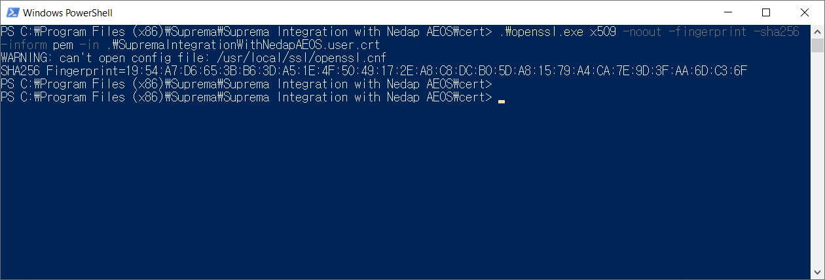
  - Go to the ‘certs’ folder under the AEOS installation directory(ex. C:\AEOS\AEserver\standalone\certs).
  - Execute the following and check the fingerprint of the User certificate. 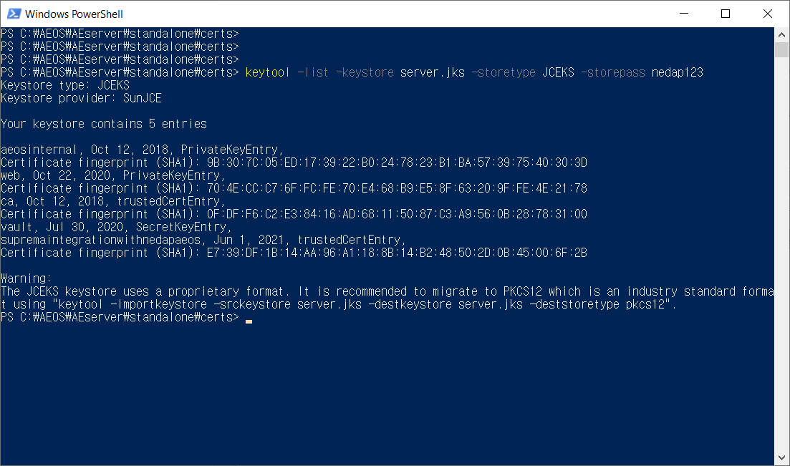
  - Make sure that the first fingerprint is equal to the second fingerprint and both the hash algorithms are the same(ex. SHA1 or SHA256).
- Check if the User certificate includes the valid IP address.
  - Go to the ‘cert’ folder under the installation directory and double-click the ‘SupremaIntegrationWithNedapAEOS.user.crt’ file.
  - See the ‘Subject Alternative Name’ item and the IP address SHOULD exist. 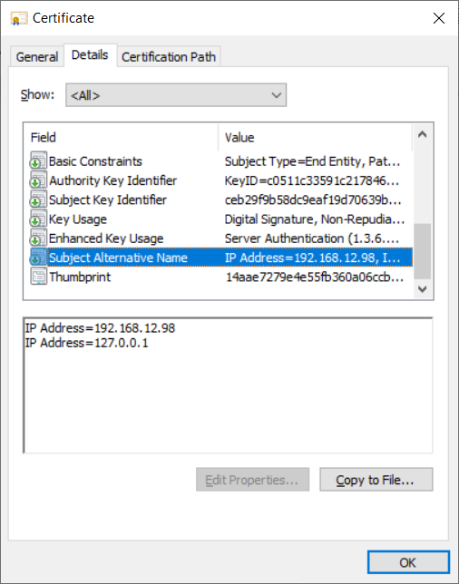
  - If the IP address is invalid, you SHOULD have to execute ‘SupremaIntegrationWithNedapAEOS_CertificateIssuer.exe’.
- Check if the AEOS configuration is valid.
  - Go to the ‘configuration’ folder under the installation directory(ex. c:\AEOS\AEserver\standalone\configuration).
  - Open the ‘aeos.properties’ file. 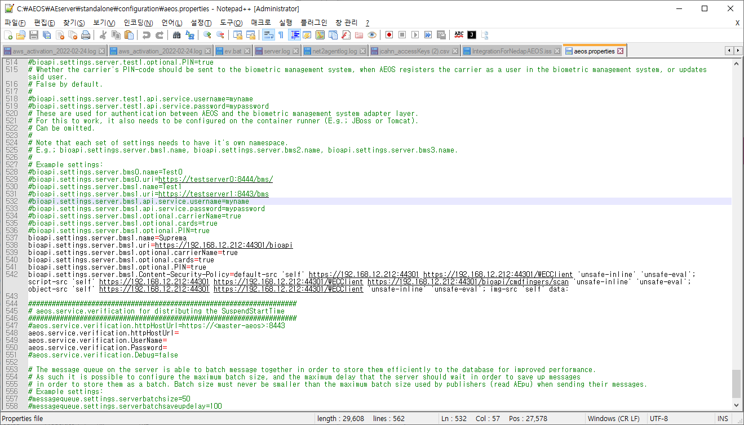
  - The BIO API settings SHOULD be valid. Above all, the IP and the ‘Content-Security-Policy’ SHOULD be set properly

How to Run the ‘SupremaIntegrationWithNedapAEOS_CertificateIssuer’
- Go to the ‘cert’ folder under the installation directory(ex. C:\Program Files (x86)\Suprema\Suprema Integration with Nedap AEOS\cert).
- Execute the ‘SupremaIntegrationWithNedapAEOS_CertificateIssuer.exe’ file. 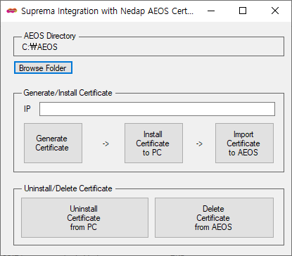
- Click the ‘Browser Folder’ button and set the path of the AEOS(ex. C:\AEOS).
- Input the your IP on the ‘IP’ text box. 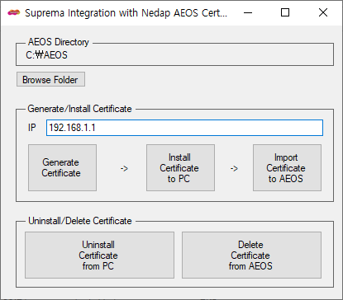
- Click the ‘Generate Certificate’ button.
- Click the ‘Install Certificate to PC’ button.
- Click the ‘Import Certificate to AEOS’ button.

